**User Guide: LIBS Interactive Peak Finder App**

Manoj Kumar Gundawara,*,#, Amal, b , and Rajendhar Junjuri,a,c, #

aAdvanced Centre of Research in High Energy Materials (ACRHEM), University of Hyderabad, Prof C R Rao Road, Gachibowli, Hyderabad, Telangana, 500046, India.

bSchool of Physics, University of Hyderabad, Prof C R Rao Road, Gachibowli, Hyderabad, Telangana, 500046, India.

cLeibniz Institute of Photonic Technology, Albert‑Einstein‑Strasse 9, 07745 Jena, Germany.

# Equal contribution

* manoj@uohyd.ac.in

Welcome to the LIBS Interactive Peak Finder App! Peak Finder App is a Graphical User Interface for Quick and Efficient Interactive Detection of Peaks in a LIBS Spectrum**.** This user guide will provide you with detailed instructions on how to effectively use this tool to analyze and identify peaks in a spectrum.

**Step1:** Download the files given in the folder.

**Step2:** If your computer already has MATLAB, run the dfdsf.exe file. Else, follow the instructions given in the readme.txt and do the necessary installations.

When the .exe file is run, the following window will appear:

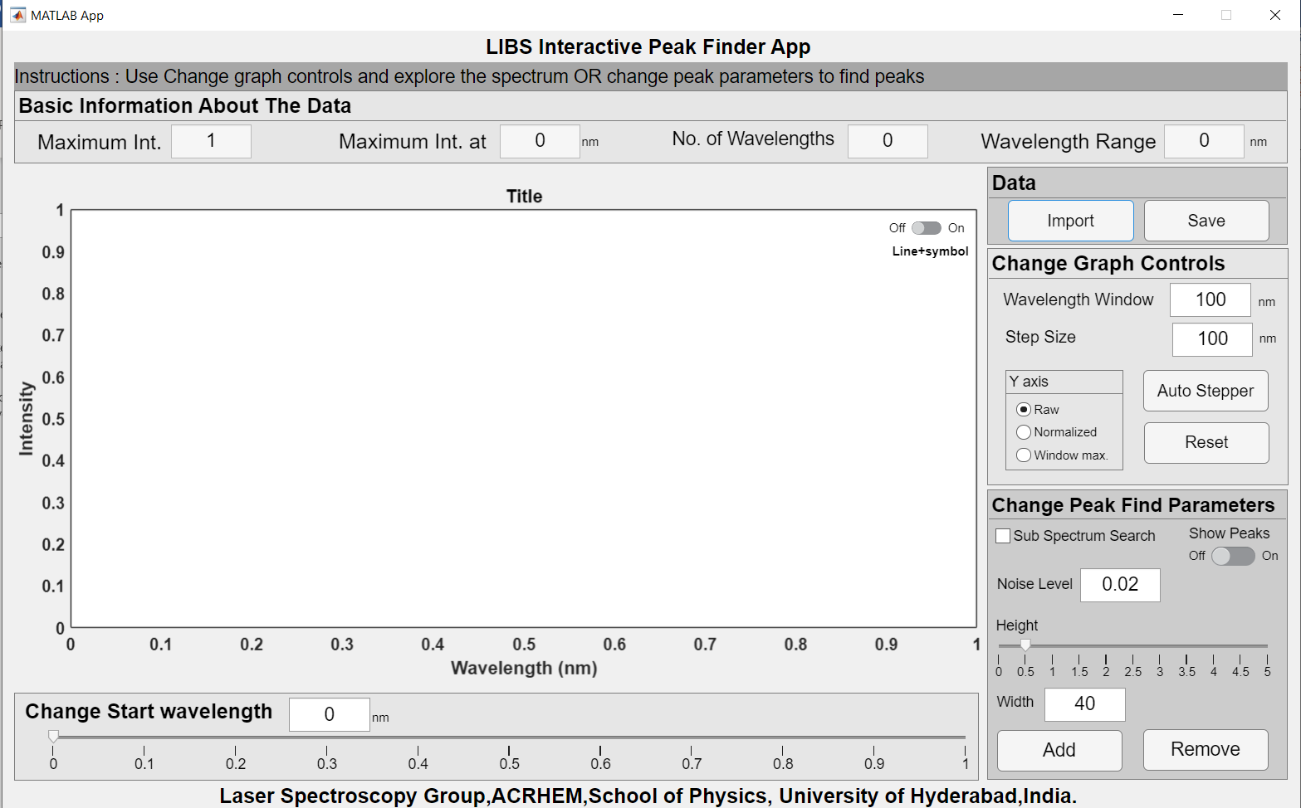

The app is divided into five major parts.

**1. Instructions Bar:**



The instructions bar shows instructions at each stage. The text changes as we navigate through the app.

**2. Basic Information about the data:**



This bar is right below the instructions bar. This shows four important pieces of information about the data. Upon importing an ASCII/CSV/text file, this area shows

1. The maximum intensity of the spectrum
2. Wavelength corresponding to maximum intensity
3. Number of wavelengths
4. Wavelength range

After using the **Change peak find parameters**, the information related to the peaks is displayed.



1. Number of peaks found by the algorithm
2. Number of peaks manually added
3. Number of peaks manually deleted
4. Total number of peaks (which is the algebraic sum of the peaks found, added, and deleted)

**3. Data:**

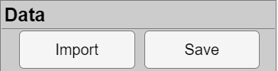**Import:** Use the Import button to import your data. The data should be in ASCII/CSV/txt format, with two columns representing wavelengths in nm and their corresponding intensities. The file should be present in the same folder as the .exe file. **Please note that there should be no column names**. Once the spectrum is loaded, either one can explore the spectrum in detail or find the peaks. It is advised to first explore the graph as it helps to understand the data in detail.

**Save:** Whenever this button is pressed, a .xls filewith the file named by appending _*peaks* to the input filename is saved. This file is saved in the same directory where the .exe file is present. The exported file consists of three sheets:

**a. Peaks:** Contains only the wavelengths and corresponding intensities of all identified peaks.

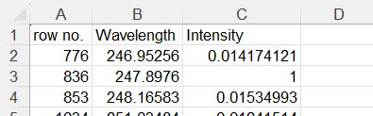

**b. Peak_labels:** Contains three columns with wavelengths, intensities of all points, and a third column indicating 1 for peak points and 0 for non-peak points.

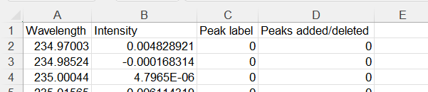

**c. Metadata:** Includes information such as maximum wavelength, search height, search width, number of wavelengths, etc.

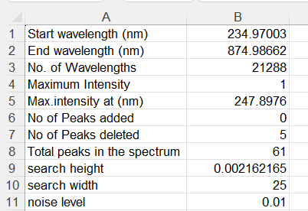

**Note 1:** Using the *Auto Stepper* button while finding the peaks saves the xlsx file automatically.

**Note 2:** If you click the save option once, an xlsx file is created for that dataset. If you click the save button after that, it only appends the peaks to the xlsx file. As a result of this you can’t remove the peaks in the xlsx file that you have already saved.

If one is interested in full spectrum search, then it is highly recommended to first finish the task of peak find, that is change the peak find parameters and get an optimum search. Particularly, the noise level must be properly adjusted to avoid noise being labeled as peaks. The save button must be pressed only after ascertaining that the optimum peaks are found. Then, it can be followed by add/remove operations.

**4. Graph Area:**

The graph area displays the graph according to the data selection. After the data is imported, full spectrum graph is displayed. There are several options that make the display and analysis easy and highly interactive. The graph along with the peaks detected looks as follows -

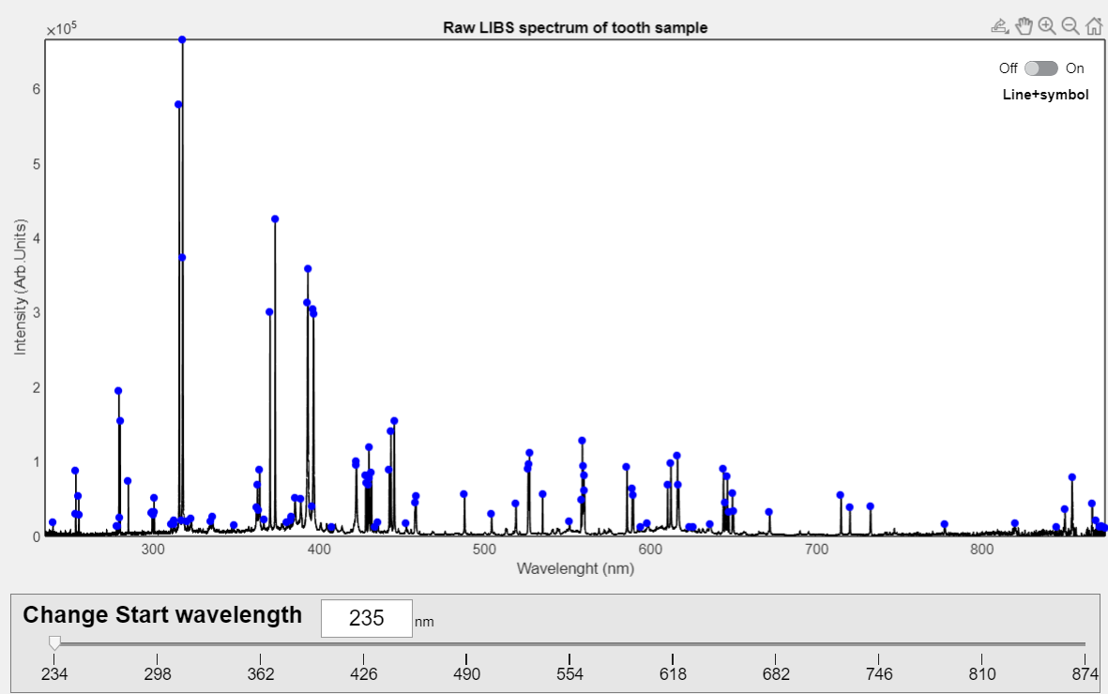

1. **Change Start Wavelength Slider:** Adjust the starting wavelength of the displayed spectrum using the slider or the input box. This will change the start wavelength of the graph.At any point, the start wavelength can be placed at the desired wavelength.
2. **Line + Symbol:** Enable this option to display each data point as a dot and connect them with lines. This feature is helpful for close examination of the spectrum. This is particularly useful while using add peak.
3. **Title Box:** Appears above the graph. The default title can be changed according to your need.
4. **Graph Area Buttons:** Located on the top right side of the graph area, you can use these buttons for various functions. This is visible when the mouse in hovered over righthand top side of the graph.

* *Save/Export:* Save the current graph area in PNG format.
* *Pan:* Move the graph area around.
* *Zoom In:* Select a specific area of the spectrum by clicking and dragging on the required region.
* *Zoom Out:* Zoom out from the current view by clicking on the graph area.
* *Restore View:* Restore the view to the default zoom for the current spectrum.

Note: While you can use the scroll wheel to zoom in and out and drag the graph area, we recommend using the provided buttons for a smoother and optimized experience.

**5. Controls:**

The controls section comprises two areas:

**A. Change Graph Controls:**

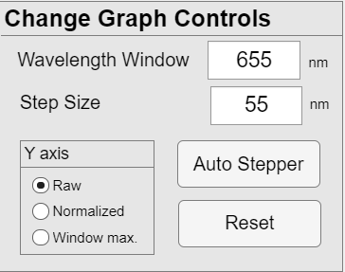

1. **Wavelength Window:** Takes a numeric entry in nm. This determines the end wavelength. The starting value is set by the Start Wavelength Slider.

End wavelength(nm) = Start Wavelength Slider(nm) + Wavelength Window(nm)

1. **Auto Stepper:** This feature is extremely useful, and it animates the graph area to scroll through the entire spectrum with a specific increment given by the **Step Size** option. The wavelength window still determines the range of wavelengths shown. The Change Start Wavelength Slider moves along with the auto stepper.

Start Wavelength(nm) = Start Wavelength(nm)+step(nm)

When the autostepper is ON, it can be paused using the same button and vice versa.

1. **Reset:** Reset the wavelength window and the auto stepper to the initial condition.
2. **Y-Axis Options:** Change the normalization of the Y-axis. Choose from three options –

* *Raw:* Shows the original values of the Y-axis.
* *Normalized:* Normalizes Y-axis to a range of 0 to 1 based on the maximum value of the Y axis in the given data.
* *Window Max:* Maximizes the value of the Y-axis within the specific region displayed in the graph area.

**B. Change Peak Find Parameters:**

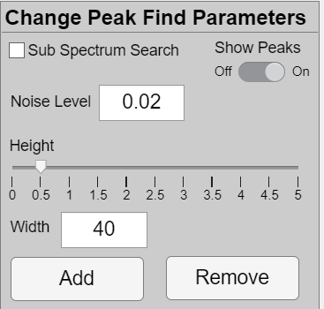

This set of controls provides different options for peak find. When any of the options are changed, its effect is reflected in the graph area. The peaks found with those settings will be displayed as blue dots. **It is highly recommended to set the y-axis to normalized before proceeding to find the peaks.**

**Show Peaks Button:** Toggle on/off to display the identified peaks in the graph. By default, it is in off state. When it is toggled to on, immediately the peaks are detected with the availed settings and displayed.

Three Main options are used by the peak find algorithm to identify the peaks:

1. **Width:** Takes an integer value. This is used for search window width.
2. **Height:** This Slider sets the value for the search window.
3. **Noise Level:** Takes a real number input and this specifies the minimum absolute Y-axis value for a given point to be considered as a peak.This can take a maximum of 0.2.
4. **Add and Remove Buttons:** Use the Add and Remove buttons to manually add or remove peaks in the spectrum. **Before doing so, turn on the Line + Symbol option in the graph area and zoom in on the required region.** This is particularly necessary when using add option. Then, select the Add or Remove button and click on the peak's intersection point using the crosshairs. Click on the point to add or remove the peak.
5. **Sub Spectrum Search:** The Sub Spectrum Search is a unique feature that allows you to search for peaks within specific wavelength ranges using different Width, Height, and Noise Level values. This option is recommended to be used exclusively with the Auto Stepper for a more precise and accurate peak analysis throughout the entire spectrum. It is recommended that the wavelength window and step size to be the same. Also it is recommended to start this exercise afresh and separately save any output file that is generated using full spectrum search.

First switch sub-spectrum search to ON.

Switch ON show peaks, if it is not ON.

Set the values for wavelength window and step size.

Now, the sub spectrum should be displayed with peaks marked. If peaks are not marked, then change any of the peakfind parameters this will show the peaks in that region. Change the peakfind parameters to obtain optimum search.

Press Save to save the peak information.

Now press Auto Stepper. Two things will change, one, the graph displays the next wavelength window and the button name of Auto Stepper changes to Pause.

Immediately press the pause button. This will ensure that the next wavelength region graph is ready for peak find. Also note that, after pressing pause, its name changes to play.

Now perform peak find in the new wavelength region.

After saving, press the play button and repeat this until the entire spectrum search is over.

Add/Remove buttons cane be used at any stage

Remember, before using sub spectrum search if the save button was pressed, then the output file already exists in the folder. Either delete it or save it with another name.